Maths on Mars User Manual:

Maths on Mars is a game intended for primary school aged students. Featuring a sci-fi theme, the game motivates its users to practice their addition and multiplication skills with easy, medium, and hard levels. The software encourages players to improve both speed and accuracy through a high score system which factors score and game duration. Upon launching the Maths on Mars software, you will be greeted with a splash screen as indicate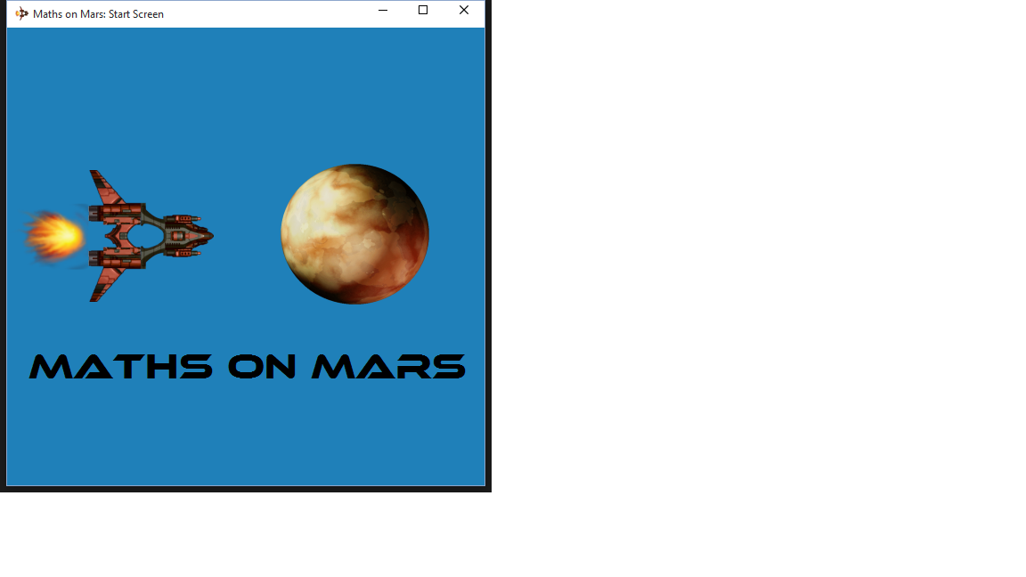d in **Figure 1.1**

Figure 1.1 – The Splash Screen

After a few seconds, this splash screen will automatically disappear, revealing the main start screen shown in **Figure 1.2**. The start screen features a help button, and a progress bar as a visual indicator of the form's completion. Simply enter your name in the appropriately labelled box, select a difficulty level, a game type, and enter the number of questions you wish to play. The “Easy” difficulty level presents numbers between 1-10 inclusive, whilst “Medium” ranges from 1-25, and “Hard” ranges from 1-100. Once completed, the Let's Go button will unlock, and the progress bar will be 100% filled as depicted in **Figure 1.3.** These instructions are also present in the help screen, shown in **Figure 1.4**.

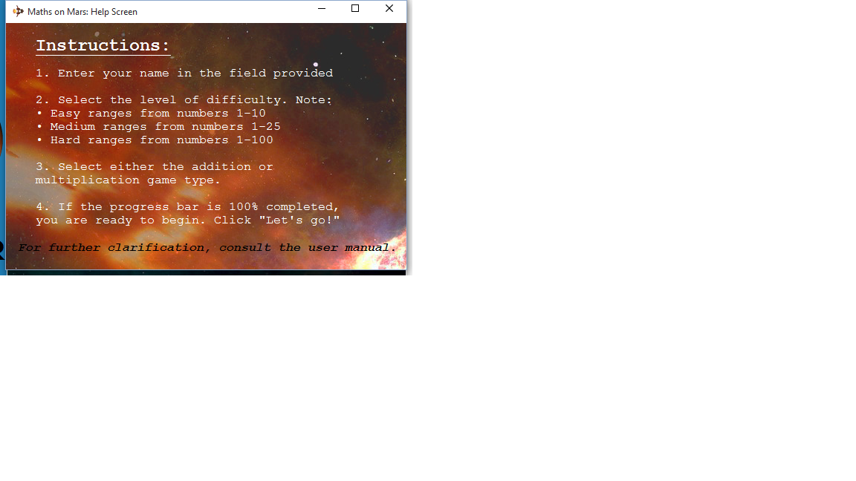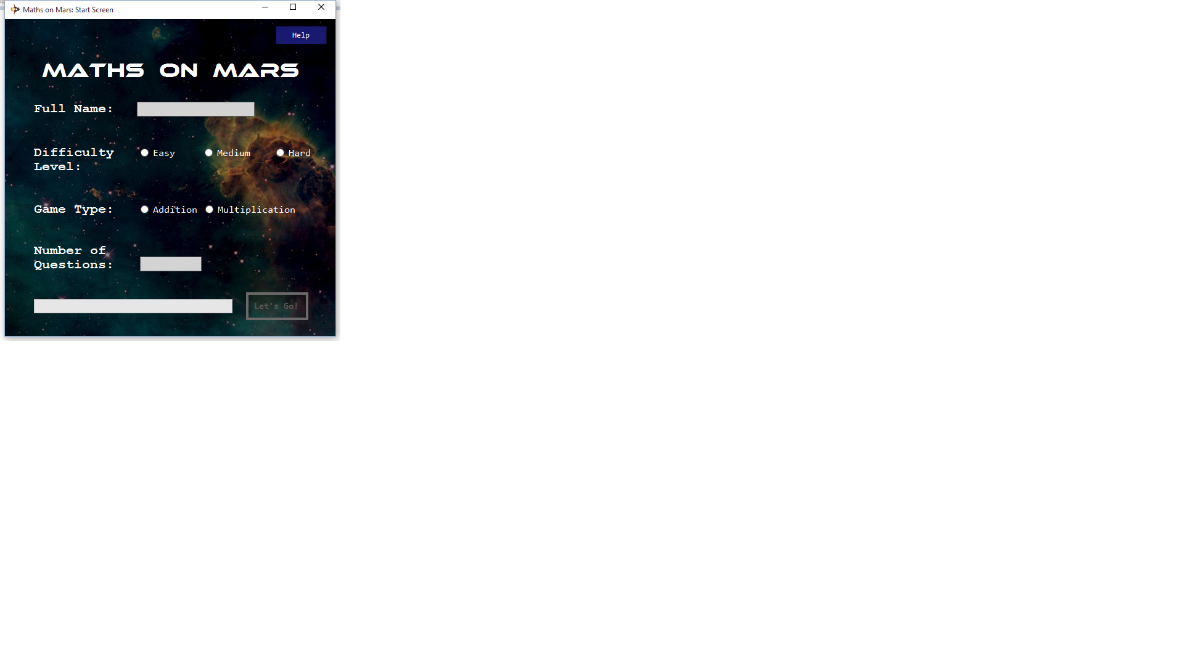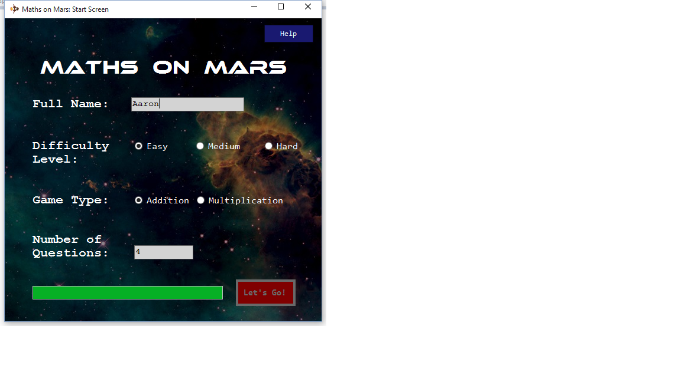

Figure 1.4 – The Help Screen

1

2

3

Figure 1.2 – The Start Screen

4

Figure 1.3 – The Completed Start Form

5

*Let's Go* button turns red on form completion.

Figure 1.4 – The Help Screen

Click to access the Help Screen.

Once you have initiated a game, the main game screen will load seen in **Figure 1.5**. On the top left is a greeting, displaying the player name and listing the game settings chosen. Located on the bottom left is the top three high scores for your chosen difficulty level and game type combination. High scores are sorted based on the score itself, then the game duration in ascending order, and then the player name. To play the game, solve the randomly generated equation by typing an answer in the input box. Answers may be submitted by pressing the submit button or the Enter key. An updating game summary is featured on the bottom right, featuring the number of remaining questions, and the number of correct and incorrectly answered questions.

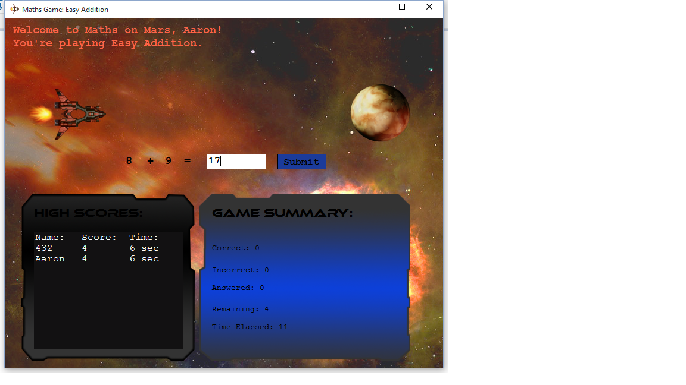

*Answer input box.*

*Greeting featuring player name & game settings.*

*Top three high scores.*

*Player's game summary.*

Figure 1.5 – Main Game Screen

As shown in **Figure 1.6**, a “Great job!” message is displayed if the answer is correct. Additionally, the ship can be seen moving towards Mars, and reaches the planet if the user achieves a perfect score. Otherwise, as seen in **Figure 1.7**, the correct answer is revealed.

*The spaceship reaches Mars if the player earns a perfect score.*

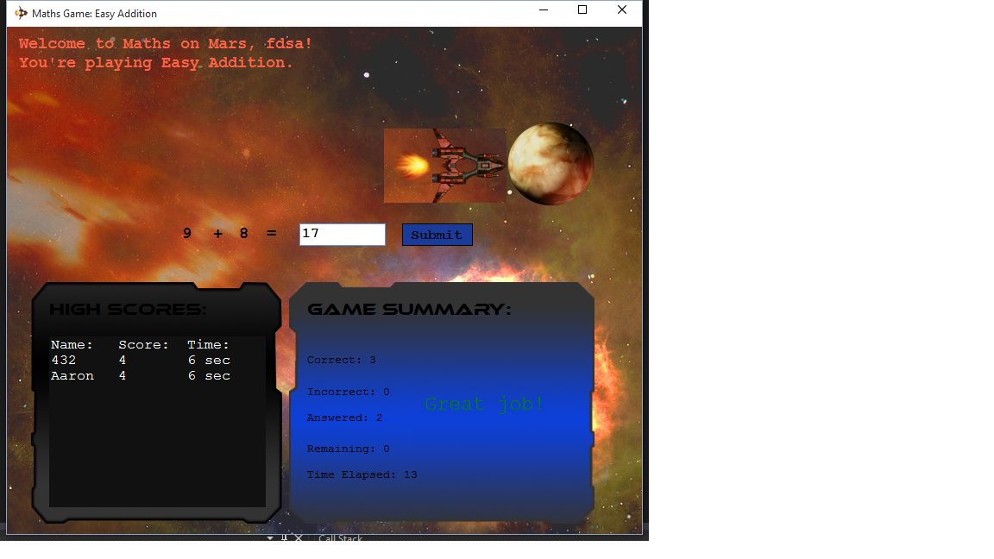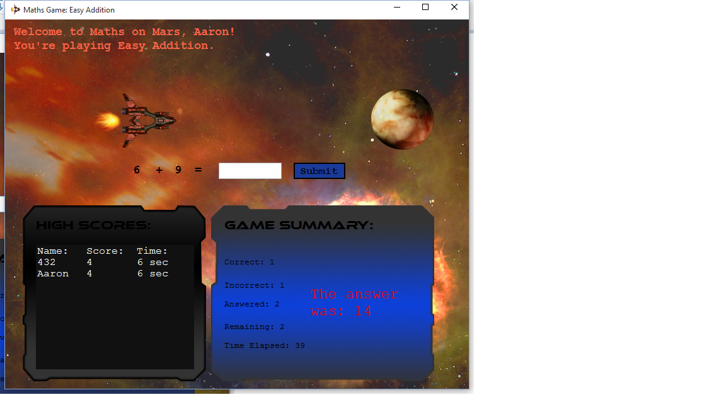

*Upon submitting an incorrect answer, the solution is revealed.*

Figure 1.6 – “Great Job” message & Spaceship Movement

Figure 1.7 – Answering Incorrectly

*The “Great Job!” received message upon answering correctly.*

*The correct answer is displayed upon answering a question incorrectly.*

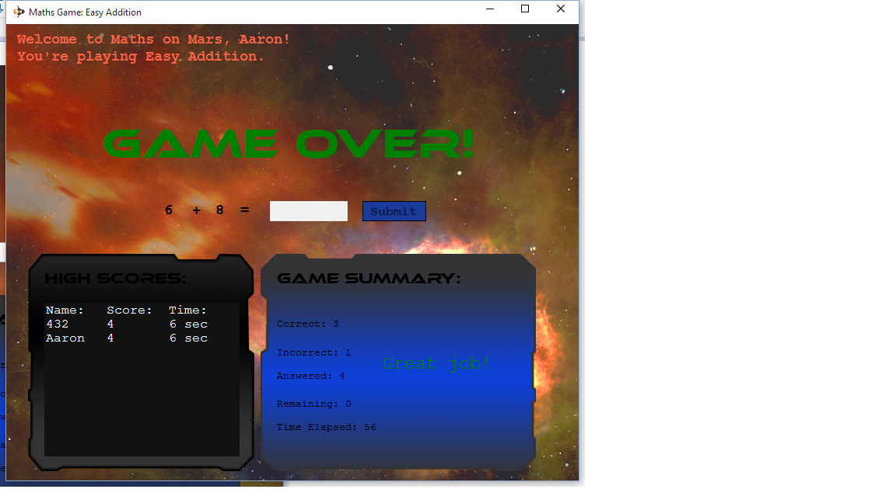Once all questions have been answered, reducing the “remaining” counter to 0, the “GAME OVER!” sequence will flash on the screen for several seconds as shown in **Figure 1.8**, before disappearing automatically.

Figure 1.8 – The Game Over Sequence

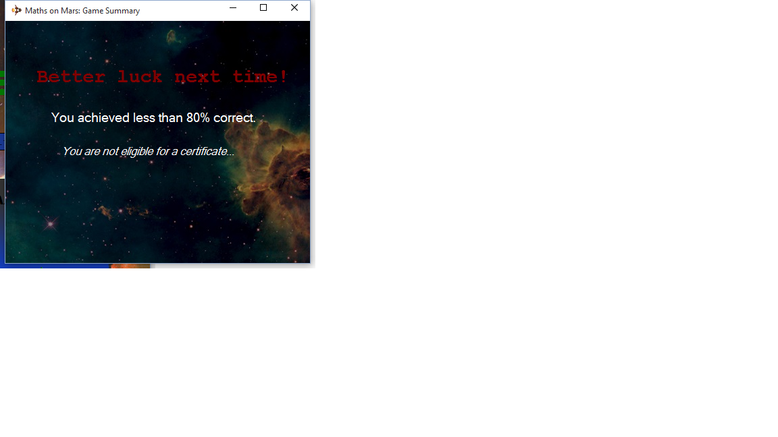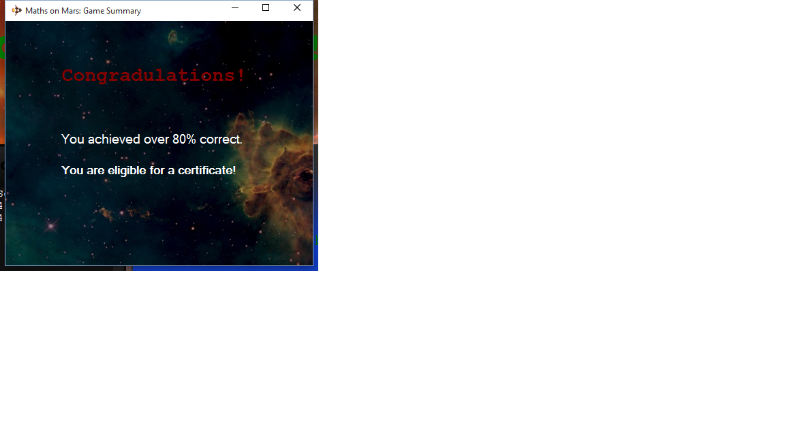When the Game Over sequence is completed, a certificate – or “game summary” window will launch. If the user gained a percentage score of 80% or more, they will receive a congratulatory message stating they are eligible for a certificate. Otherwise, a message will be displayed stating “better luck next time!”, and a certificate will not be awarded.

Figure 1.9 – Over 80% score, certificate achieved.

Figure 2.0 – Less than 80% score, no certificate.